**Business Intelligence and Analytics**

**ISMG 6220/BUSN 6812**

**BI Project**

1. **Summary**

The revenue trends graph consists of line graph Revenue, Calendar Date and Location Description. Location Description gives three results B.B Brooklyn (blue), B.B Lower Manhattan (red) and B.B Upper west side (green). In second visualization i.e. Average Revenue vs Order Count by Date of Week that shows percentage of average revenue and average order count of minimum value of 275 and maximum value of 1331. Third visualization is order and item count correlation that shows bubble graph of the three-location description that increases linearly.

In worksheet two, first visualization talks about the average score by zip code in New York city, percentage of average score shows the different level of percentages in different color sections. The second visualization shows revenue performance vs average health score that have three business names called B.B Brooklyn (blue), B.B Lower Manhattan (red) and B.B Upper west side (green) in bubble graph. The graph consists of Inspection date, average revenue and average score. Lastly, visualization three shows D3 bubble chart called average scores by boro.

1. **Screenshots of both sheets**

Worksheet 1:

Visualization 1 (**Revenue Trends**)

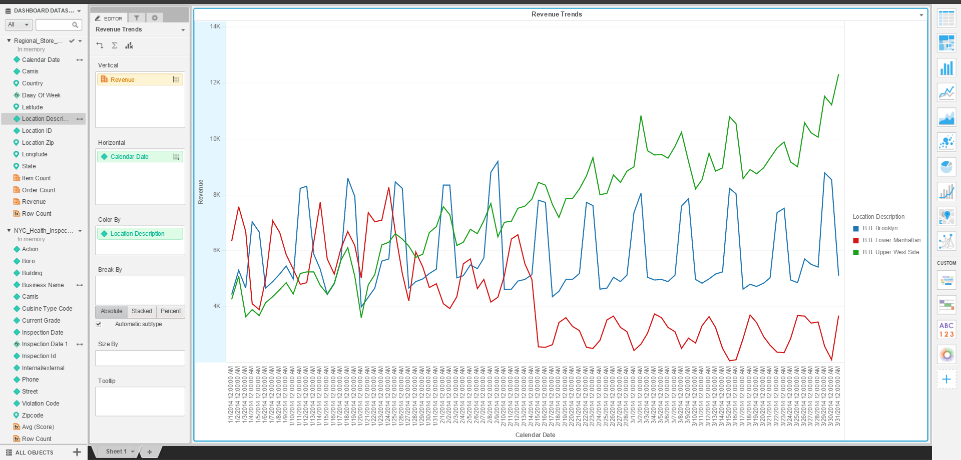

Visualization 2 (**Avg Revenue vs Order Count By Day of Week**)

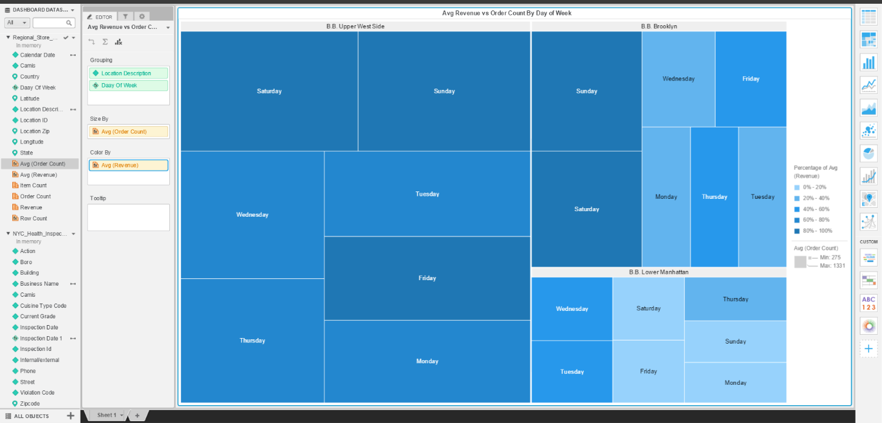

Visualization 3 (**Order and Item Count Correlation**)

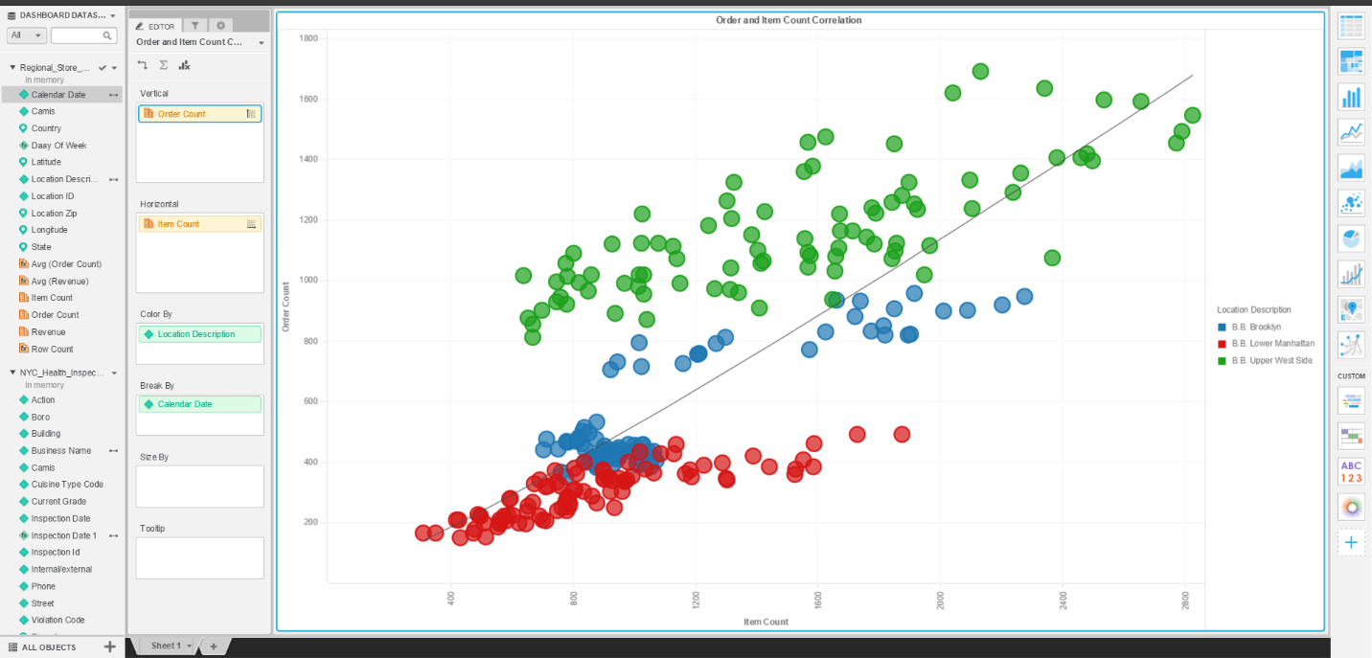

Worksheet 2:

Visualization 1 (**Avg(Scores) by ZipCode**)

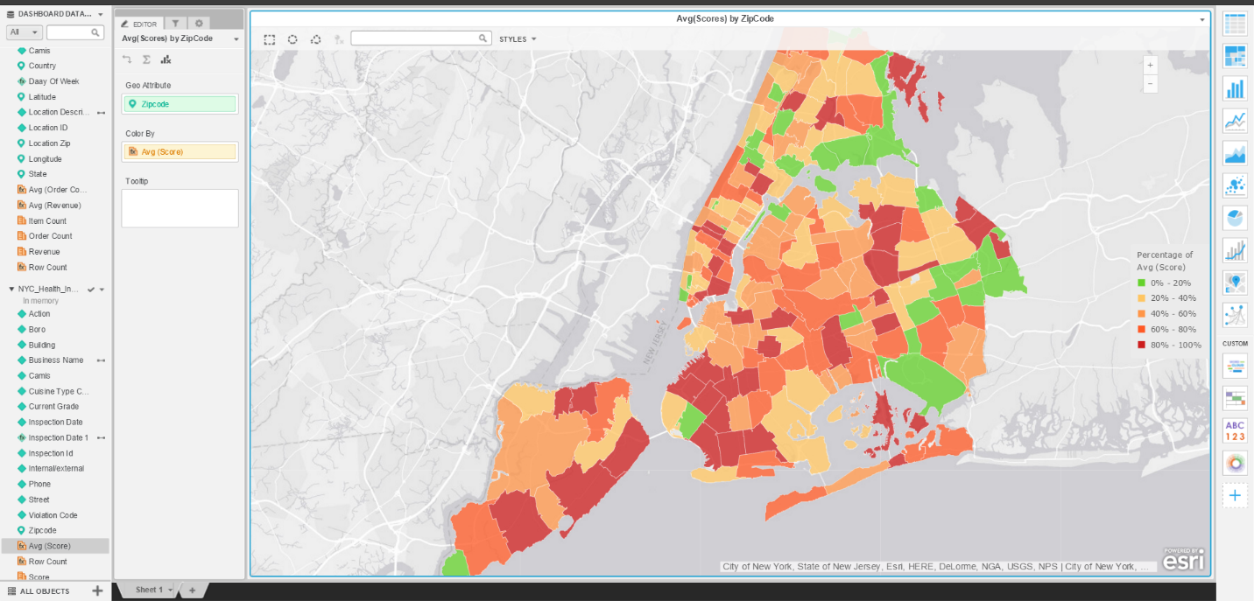

Visualization 2 (**Revenue Performance vs Avg Health Score**)

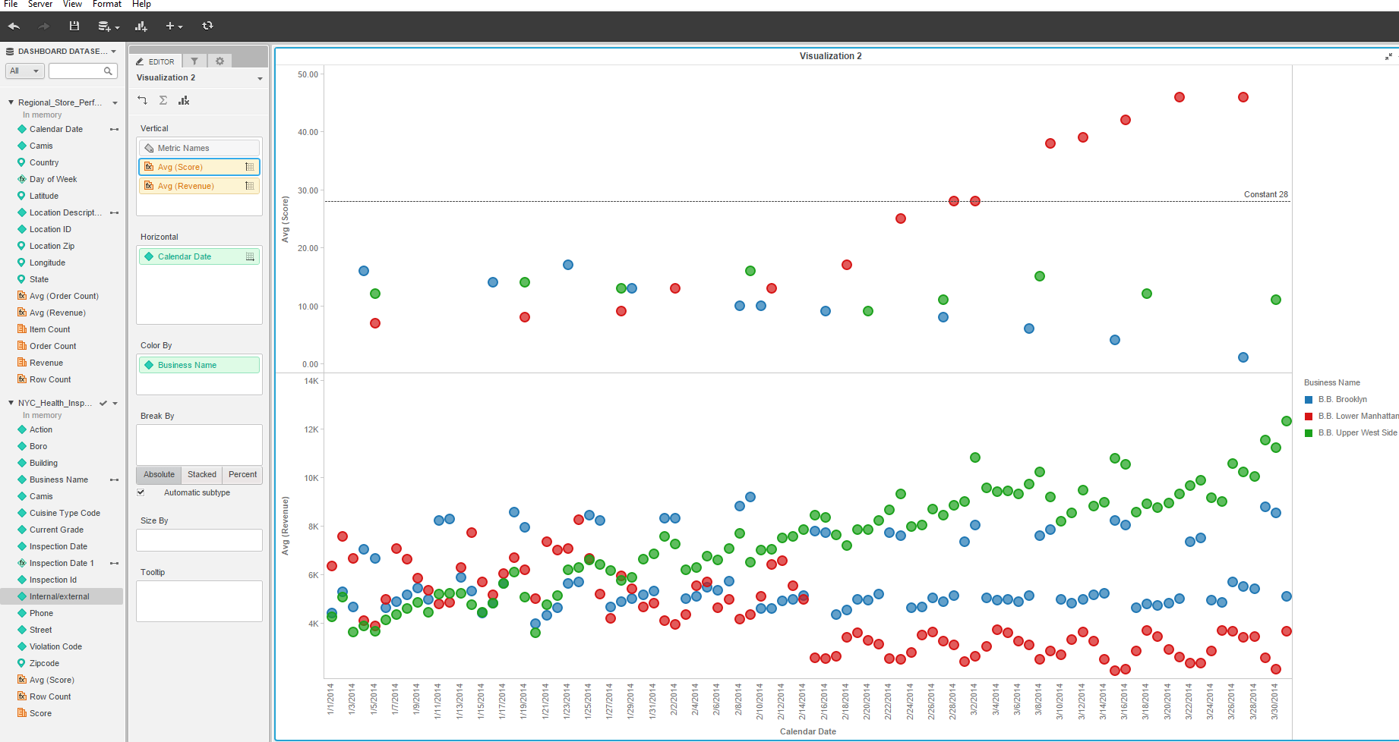

Visualization 3 (**Avg(Scores) by Boro**)

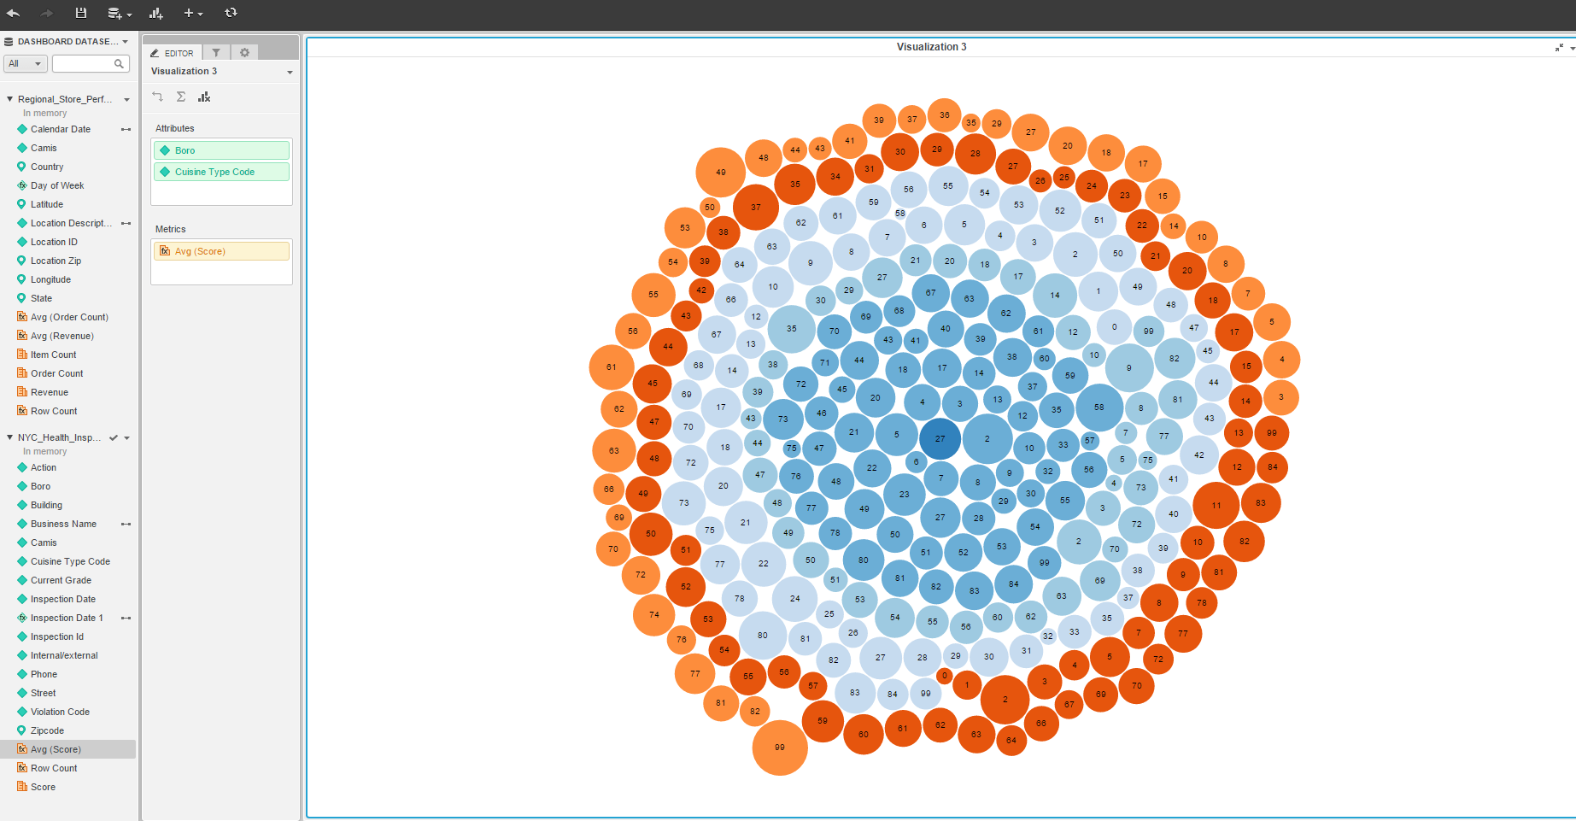

1. **Screenshot of script**



1. **Strength/weaknesses of Micro Strategy BI Tools**

Strength of Micro Strategy:

* Quality of client references
* Launch of Micro Strategy 9
* Innovation in mobile BI
* Lower administration cost paradigm
* Strong customer support
* Product strengths

Weakness of Micro Strategy:

* Challenges associated with organic growth in a consolidating market
* Dependence on a big deal to grow
* Low market share in emerging markets
* High learning curve for end users and developers
* Lack of performance management capabilities of its own

1. **Recommendations**

Micro Strategy is a great tool and has a good front end for complex SQL reports and is very easy to use from an end user perspective. The UI is not very polished and requires significant hardware investments. It allows the users to make actionable decisions based on the data in a quick manner.

Some of the features of Micro Strategy are:

* Ability to access data offline
* Data security
* Ability to utilize full mobile experience, such as access to GPS
* Downloading big data to device during off-performance hour.